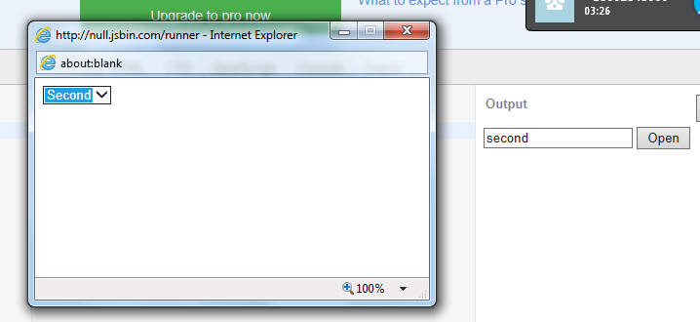

<!DOCTYPE html>

<script>try{window.open=function(){};window.print=function(){};window.alert=function(){};window.prompt=function(){};window.confirm=function(){};}catch(e){}</script>

<html>

<head>

<meta charset=utf-8 />

<title>JS Bin</title>

<style id="jsbin-css">

</style>

</head>

<body>

<input id="value" />

<button onclick="openWindow();">Open</button>

<script>try {function openWindow() {

var i, l, options = [{

value: 'first',

text: 'First'

}, {

value: 'second',

text: 'Second'

}],

newWindow = window.open("", null, "height=200,width=400,status=yes,toolbar=no,menubar=no,location=no");

newWindow.document.write("<select onchange='window.opener.setValue(this.value);'>");

;window.runnerWindow.protect({ line: 12, reset: true }); for(i=0,l=options.length; i<l; i++) {;

if (window.runnerWindow.protect({ line: 12 })) break;

newWindow.document.write("<option value='"+options[i].value+"'>");

newWindow.document.write(options[i].text);

newWindow.document.write("</option>");

}

newWindow.document.write("</select>");

}

function setValue(value) {

document.getElementById('value').value = value;

}

} catch (error) { throw error; }

//# sourceURL=uqamiz.js

</script>

</body>

</html>

<!--jsbin live harness--><script>try{delete window.print;delete window.alert;delete window.prompt;delete window.confirm;delete window.open;}catch(e){}

</script>